Computer Vision – Week 4

Anh Huy Bui – 293257

2. Line 1: b = 2\*m + 1

Line 2: b = -2\*m + 5

Intersection: [m’ b’]T = [1 3]T

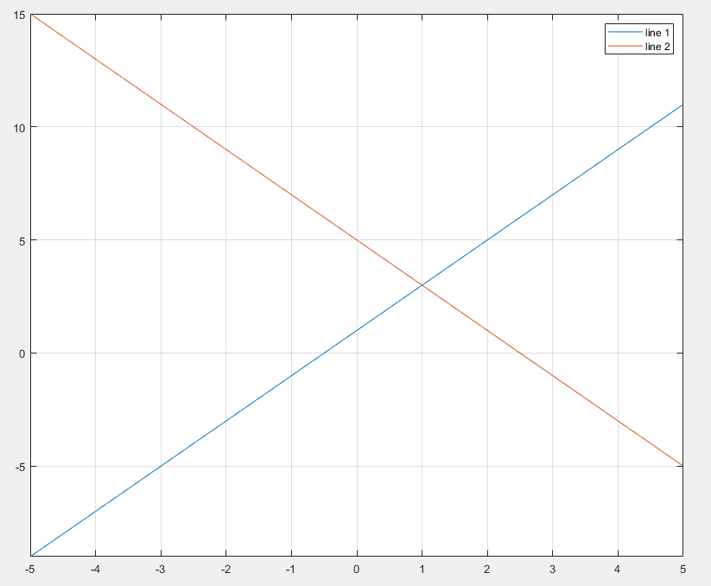

1. Sinusoid 1: ρ = (-2)\*cosθ + sinθ

Sinusoid 2: ρ = 2\*cosθ + 5\*sinθ

Intersection [-π/4 -2.12]T

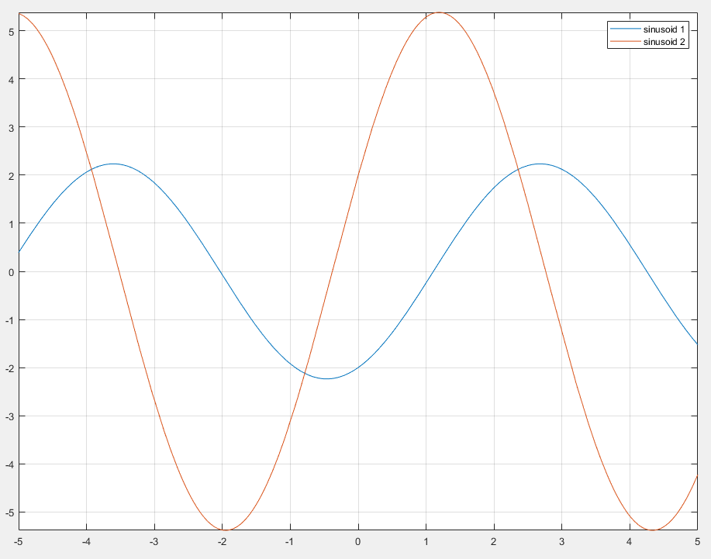

1. Polar Coordinates helps simplify the algorithms, provides an easier method to detect lines
2. Output

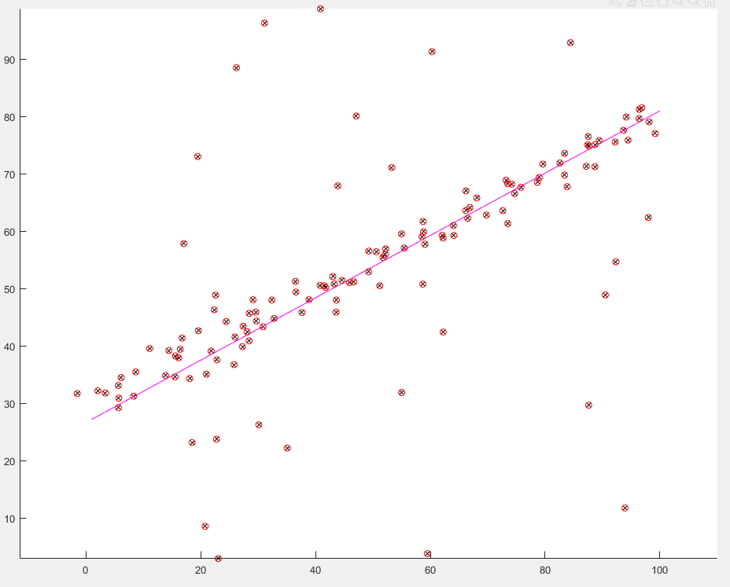

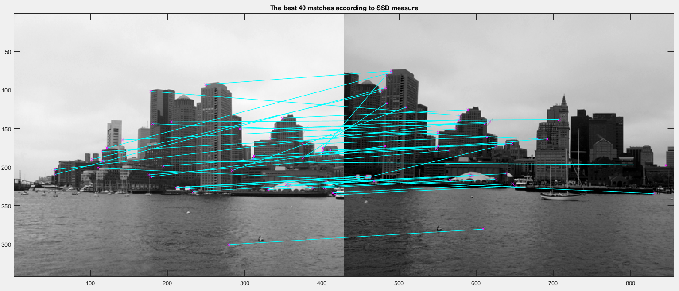

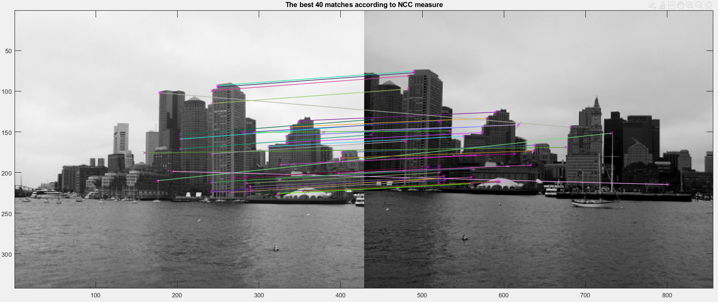

Evaluation: NCC in this case works better SSD. This is because 2 images have different brightness or in other words, range of pixel values of 2 images are different; SSD directly compares differences between the sliding windows of 2 images, which results in less similar result while NCC first normalizes the difference of 1 image with its own mean value to range of 0 to 1 then calculate the end-result.

Conclusion: NCC can perform well regardless of brightness difference of images. SSD, in the other hand, is a simpler and lower-cost method.

2. NNDR (5 correct matches) performs better NND (2 correct matches) because it takes both nearest and 2nd nearest neighbor into account.

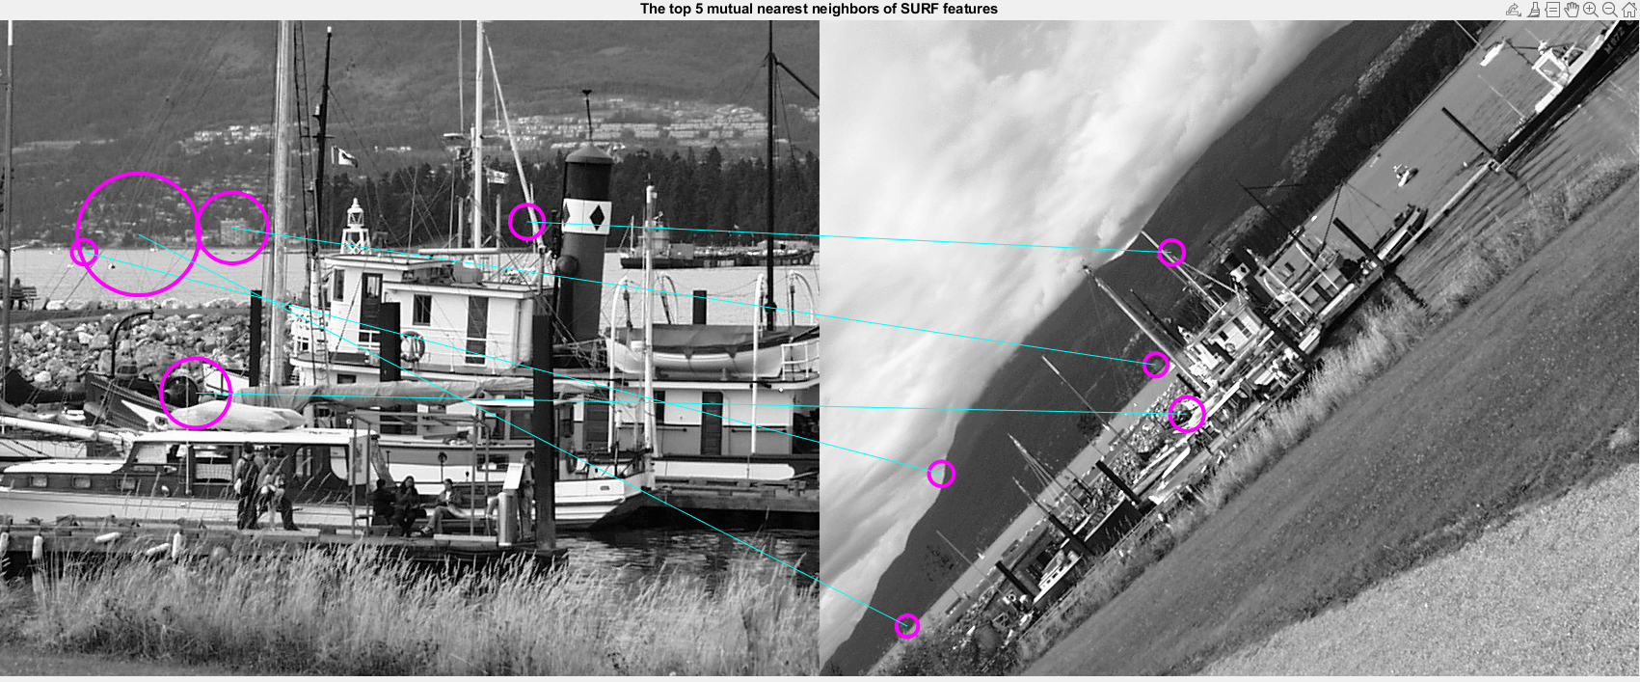

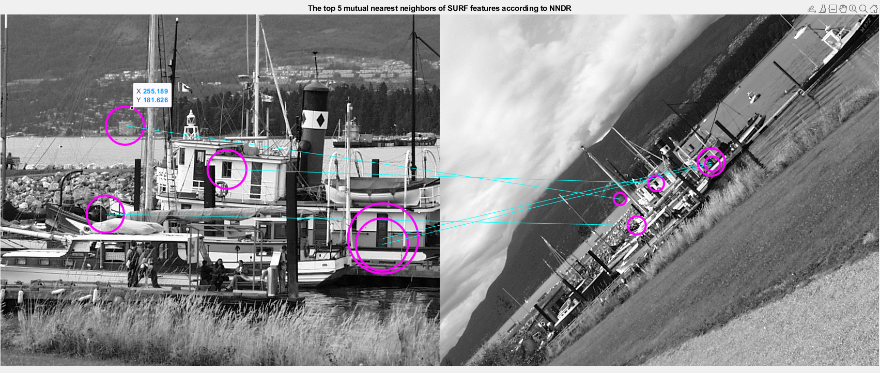

1. Harris Corner detect significant changes in pixel intensity while SURF applies Gaussian second derivative mask to an image at many scales. Therefore, Harris Corner works best only when the images are high contrast, or has objects with highly different colors, SUFT can work well in general with run time trade-off.